Instructions: You may complete most of the exam either in Excel or on paper (a word document with questions will follow). In general, include explanatory text whenever possible. The point is not just to reach the correct numerical answer but is to demonstrate to the reader that you know how to do things. Every sheet should be self-documenting! In most cases, the ""space"" for your answer has been shaded, but use your judgment to produce a document that I can follow to understand how you went about attacking a given problem.

All of these problems are loosely organized around the idea of substance abuse as a policy problem (and you will note that in some case I mean very loosely!).

I hope it gives you a chance to show what you can do."

- Chris has a headache and wants to try some new-fangled aspirin-like medicine. It turns out that the drug is a little bit variable in its effects. Some pills of this drug are fast acting, some are slow acting, and some are duds. A fast acting pill has an effect in 20 minutes. A slow acting one takes up to 40. Sometimes people who have taken a slow one think they have taken a dud and so they take another one. This is bad news if the first one just hadn't kicked in yet and an overdose of this medicine is not good for you. Assume that 40% of pills are fast, 40% are slow, and 20% are duds. What does the event tree look like if people who don't feel a effects after 20 minutes always take another pill? The template may be helpful

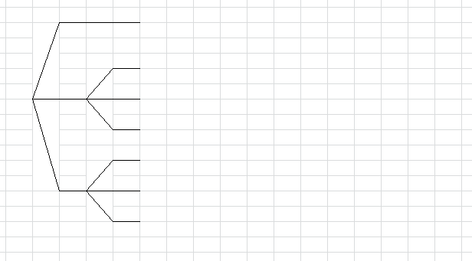
- If not getting rid of the headache is "priced" at -10, getting "cured" is worth 15, and overdosing makes the headache worse and so is -15, should she take a pill or not? What if it doesn't start working after 20 minutes?

- The new kid on the block is feeling a lot of peer pressure. She really wants to fit in, but she also wants to stay out of trouble and not get her parents mad. She is trying to decide whether to participate in some possibly illegal and possibly dangerous partying that all the cool kids are engaging in, chugging the new softdrink with double extra sugar. She has the choice to join in or to refrain. If she joins in, she estimates, there is a 40% chance that she'll have a great time and score popularity points (worth 10 emotional units). There is a 30% chance she will do something stupid but have fun doing it (worth 3 emotional units). There is a 20% chance no one will notice anything (0 units) and a 20% chance she'll go home with an obvious sugar high and get in a heap of trouble (-20 emotional units). On the other hand, if she decides to refrain there is a 50% chance no one will notice (0 units) and a 25% chance she'll be scorned for being uncool (-30 emotional units) and a 25% chance she'll be admired as on of the cool straight-edge kids and make some new friends (+5 units). What should she do?
This template might be useful (cut/paste/etc. as you like -- you might not need four branches in every case)
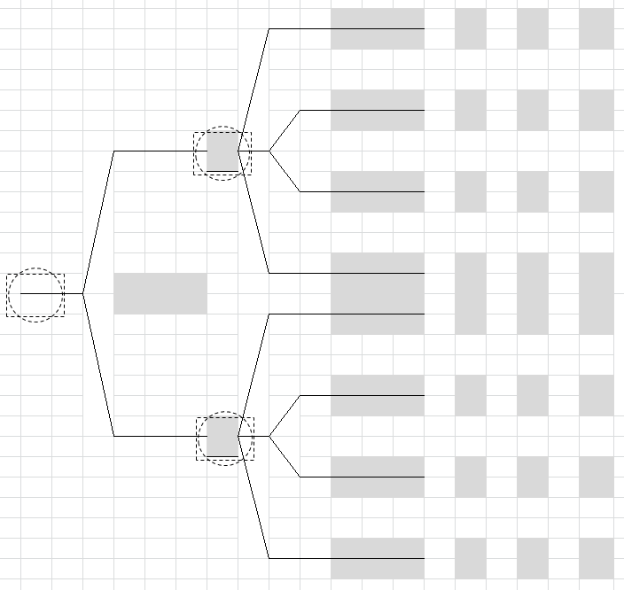

- There is a test for whether someone is a cool kid or not, but unfortunately, it is not a perfect test. When administered to truly cool kids it detects their coolness correctly 70% of the time. When administered to uncool kids it correctly identifies their uncoolness 83 % of the time. Serious research has shown that of all the kids, about 37% are cool. Flip the tree to tell us how much faith we should put in the new kid's coolness if the test declares her cool.
- What happens to our faith in the test if the actual % of kids who are cool is much lower than this?

- For treating X there are two new drugs, A and B. A ($10 dose) is much cheaper than B ($45/dose) and it works in many (67%) cases. B almost always works. If you take A and it doesn’t work in a week, you can take B but you have to take a double dose.

There is a diagnostic test to see which strain of X you have so that you will know if drug A will work. What is the most we should pay for the test?

Unfortunately, in Rtown the number of addicts needing treatment always exceeds the supply of treatment beds so the treatment facility is always full. It's capacity is 100 and the program is 4 weeks so each week 25 people transition from "In Treatment" to "In Recovery" and 25 addicts enter the treatment program. The community has a number of programs to support persons in recovery after substance abuse but they are not 100% effective. In fact, in any given week 2.5% of those in recovery relapse and start using again. In the community as a whole it is estimate that each week 10 new people become addicts (separate from those who relapse).

- If we model just the "in recovery" population using difference equations, what are the "rates" and what are the "amounts"?

- Write out the difference equation in standard form.

- Solve for the equilibrium value, if there is one (and explain/show how you do it).

- What if we wanted to model the addict population? What are the rates and what are the amounts?

- Suppose the threshold schedule below described how likely adolescents are to experiment with drugs based on their perceptions of how many other kids are experimenting with drugs. The first column is the % of kids believed (by the population of kids) to be experimenting and the second column is the number who would themselves decide to join in if they believed a given level of peers were experimenting. The third column is the cumulative frequency.

% Believed to be Doing Drugs | % Who Would Do Drugs If So | Cumulative %
0 | 12 | 12
5 | 0 | 12
10 | 0 | 12
15 | 2 | 14
20 | 3 | 17
25 | 3 | 20
30 | 4 | 24
35 | 5 | 29
40 | 7 | 36
45 | 7 | 43
50 | 8 | 51
55 | 9 | 60
60 | 8 | 68
65 | 7 | 75
70 | 2 | 77
75 | 1 | 78
80 | 0 | 78
85 | 0 | 78
90 | 0 | 78
95 | 0 | 78
100 | 0 | 78

- Plot this data along with a 45 degree line and describe how the system behaves. If there are equilibria, where are they? What kind of equilibria are they?

- How could a policy maker use this analysis to argue for funding for a public awareness campaign that was designed to get the level of experimentation (or at least the perceived level of experimentation) down below about 50%?

- Consider what some have called the "substance abuse system": some people are abstainers, some casual users, some addicts, some in treatment, and some are in recovery.

Suppose that in any given time period 2% of abstainers try drugs and 50% of these become casual users (that is, the transition from abstainer to casual user is about 1%. During the same period, 2% of casual users become addicts and 20% revert to being abstainers. Of all addicts, 10% go into treatment in a given time period and 1% go cold turkey and become abstainers. Treatment takes 4 time periods and so on average 25% move to recovery each time period. Of those in recovery 10% relapse in any given time period. And suppose current definitions were that after 50 months (we would record this as a 2% chance of transition) in recovery one was declared "clean" and re-categorized as "ABSTAIN."

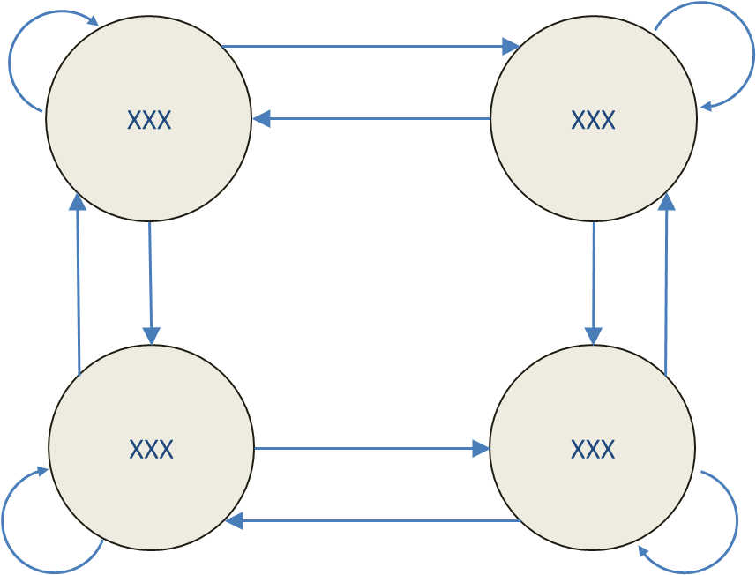

- Label the states and insert the transition probabilities in the diagram above
- Set up the transition matrix

- Make a table of the states over time and, allowing all to start out in "ABSTAIN" trace the system out over 100 time periods
- Plot the results.
- Comment

A local treatment center has two types of mobile health outreach vans. Type 1 and Type 2. Type 1 has a capacity of 10 acute cases per day and a routine case capacity of 40 patients per day while Type 2 has the can handle 40 acute cases and 20 routine. A needs survey suggests about 3,200 acute cases (160 per day) and 4 400 non-acute cases each month (220 per day). The cost per hour of operation of a Type 1 is $30, and $40 for Type 2. How many trucks of each type should the hospital put on the street to make the best use of available funds? Type 1 trucks require 2 staff and type 2 5 staff. We want to keep staff at or below 23. Also we have a limit of 7 drivers (not included in staff).
- Identify the variables by changing the "varN" labels below
- Identify what the weights in this problem are (what are we optimizing?) and put the appropriate numbers in the grey cells.
- Put the formula for the objective function in the blue cell.
- Label the constraints (under the word "Constraints" below) and input the correct numbers in the pink cells
- Put the correct formulas in the cells in column I
- Note whether the constraints are GEQ, etc.
- 7 Put the limiting values in column K
8 Use Solver or graphically identify the solution.
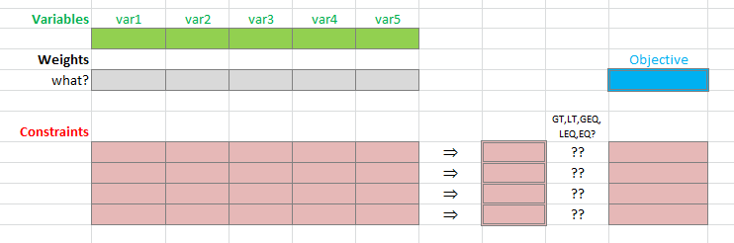
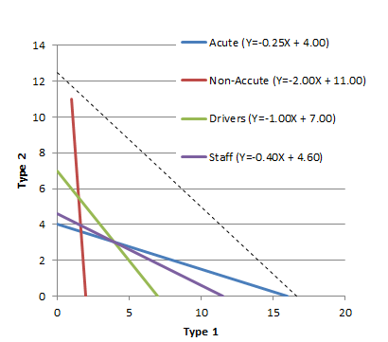

- A Monte Carlo simulation involves probabilistic behaviors, usually implemented using a random number generator (in Excel we can use the function =rand() which delivers a random number x, 0≤x<1).

To generate numbers in another range (for example, whole numbers 1 to 6 for the role of a die) we can use a formula such as
=1 + int(6*rand())

which says multiply the random number by 6 (resulting in a number between 0 and 5.999999) and then take the integer part of this number (resulting in 0,1,2,3,4,or 5) and then adding 1 to this to shift it to 1,2,3,4,5 or 6.

- Use this technique to fill in the parts of a simple Monte Carlo simulation of 50 rolls of three dice.
- Include a formula to calculate the total of the three dice.
- In cell H4 write a formula that computes the average of the total over 50 rolls.
- In cell range J4:K19 create a frequency table for the results (tallying the totals of each roll of three dice)
- To the right, create a histogram of this frequency data, nicely formatted and labeled.
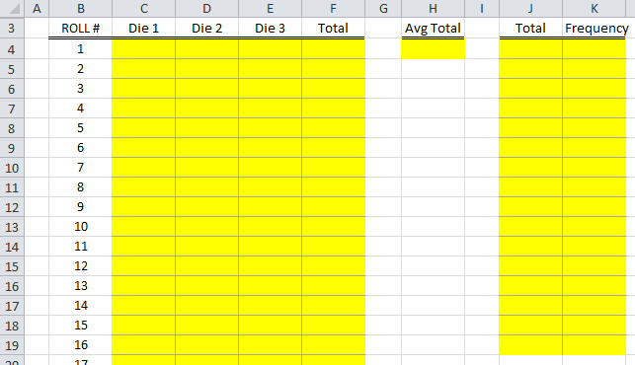

- Create an Excel worksheet on which you implement the following:
- Create a spinner that controls cell D3, allowing it to range between 0 and 100.
- Put a formula in cell F3 that uses the contents of D3 to range between -50 and +50
- Add conditional formatting to F3 so that it turns yellow when its contents are less than or equal to 0 and red when it is greater than 0
- Merge cells D5:G5 and put a formula in them that writes a text message describing the contents of cell F3 as follows:
  - if F3 is less than zero it should say "N is a negative number" (where N is the actual value of F3 - using the TEXT() function)
  - if F3 is greater than zero it should say "N is a positive number" (again, where N is the actual value)
  - if F3 is equal to zero it should just say "F3 is nuthin!"

