Goals
We want to become familiar with the purpose, style, and logistics of the course and lay some conceptual and practical groundwork.
Agenda
16:00-16:05 (5) Settling In
16:05-16:15 (10) Who Instructor? Why Course?
16:15-16:35 (20) Ice Breaker
16:35-17:00 (25) Justice+Innovation+Startup+Lab
17:00-17:30 (30) Design Thinking 101
17:30-17:40 (10) Review Syllabus
17:40-17:50 (10) Next time

1 Who is the instructor and why this course?
10 minutes
Dan introduces himself and explains the background of the course. IYA/LAW.
2 Ice Breaker: Visual Telephone
20 minutes
Materials: One sheet 8 ½ x 14 paper per person and something to write/draw with. Instructions: sit in circle; along top inch of paper write some personal statement about the world; fold over; pass left; unfold, read, refold, draw a representation of what you read, fold over; pass left; unfold just one fold; look at picture; refold; write a sentence or phrase that captures what you see in the picture. Repeat.
3 Justice+Innovation+Startup+Lab
20 minutes
Instructions.Slides.
4 Human Centered Design 101
30 minutes
Instructions. (a) Form teams of three. (b) Each team member will watch one of these three short videos. As you are watching, make note of any terms or concepts the presenter seems to suggest as particular to human centered design.
What is human-centered design — and why does it matter?
DevEx

https://youtu.be/0bxtEqM2TQU
Human Centered Design
Grameen Foundation

https://youtu.be/6mcZKWhjr9o
Human Centered Design for Social Innovation,
IDEO.ORG

https://youtu.be/ijgDsabeHeY

(c) Write a one or two sentence definition of “human centered design.”
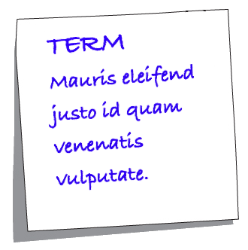
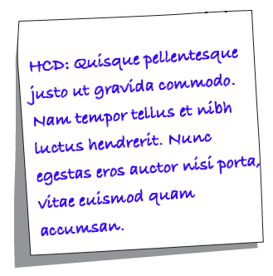
(d) Jot down any terms you heard and give each a preliminary definition that conveys how you heard the term.

(e) Now sit with your team and, starting with whoever had the most recent birthday, share your findings following this protocol:
Go clockwise around the group. No one speaks for more than 30 seconds. Read exactly what you have written down each time.
Start with your definitions of human centered design. The first person reads her definition and posts her note in a shared posting space. The next person then reads their definition and the group talks about differences in the definitions. And then repeat for the third team member.
Next we turn to terms and concepts. First person posts their term and reads their definition. Then, starting with the person to their left we ask if the next person had the same term and if so to read their definition and identify what is added or different. And then same for team member 3. And then team member two puts a term or concept up and we proceed clockwise in the same manner. Continue until all identified terms have been talked about.

5 Syllabus Review
10 minutes
Just that.
6 Next Time
10 minutes (to 5:50)
Next class session we will W: Problems worth solving; Solutions worth pursuing
In this class we introduce the idea of problems worth solving along with strategies for identify them and the criteria by which we will judge a solution as worth pursuing
Readings
- TEN Innovate. How to Identify the Big Problem worth Solving
- Austin Center for Design. Wicked Problems: Problems Worth Solving
- Kumar, Manu. 2015. Finding a Problem Worth Solving
- MacArthur Foundation. 2016. One Hundred & Change Press Release(see also Scoring Rubric)

