104. House gets another case. There's this funny rash. We won't say where it appears, but it's a funny rash. In 1% of the cases, it means something really, really bad — anxoreisis. Fortunately, there's a test. Unfortunately, it's not a perfect test. Fortunately, it's a pretty good test. Unfortunately, it is wrong 2% of the time. Work it out.

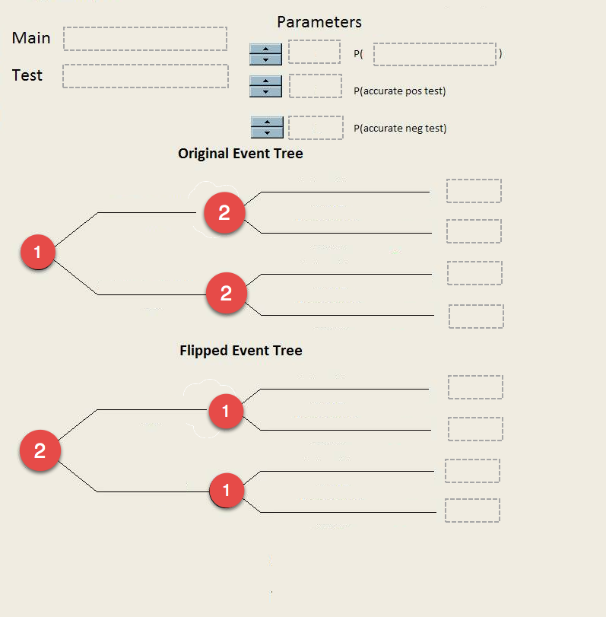

Q103. Suppose we are running a program to which we want to accept only individuals in the top 25% of the population (on some measurable trait). Unfortunately, our test for measuring the trait is only 80% accurate. Draw event tree and flip to show what kind of faith we can have in the test results. Which test result appears more worthy of taking at face value? Which group would you be inclined to develop a second test for?

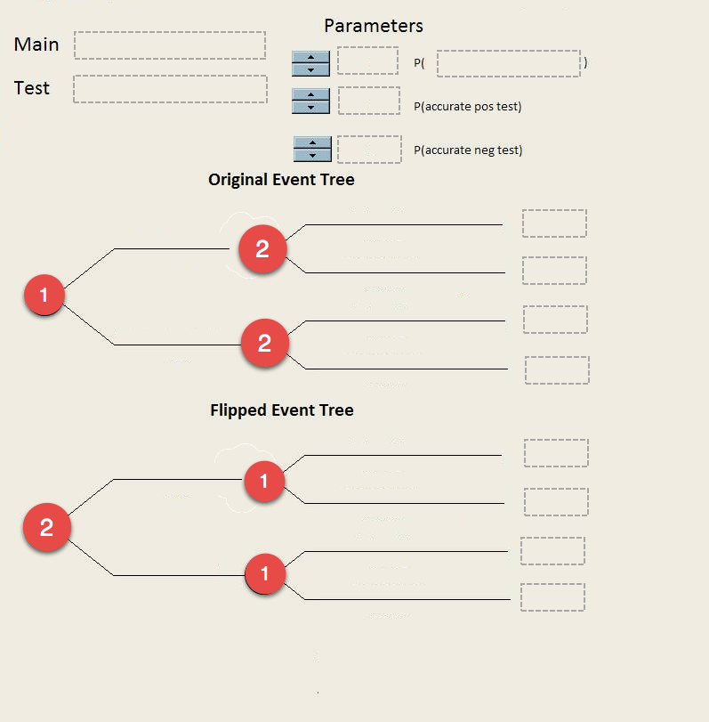

Q102. Kids these days! Of those who get into trouble, it turns out, about 30% are "real trouble-makers" who need some help. The other 70% are normal adolescents who will age out of their trouble-making under normal care. A social worker friend introduces you to a test that you can give to kids who are referred to you to determine which category they are in. Research has suggested the test is 75% accurate. Use tree flipping to describe what to make of the test's results.

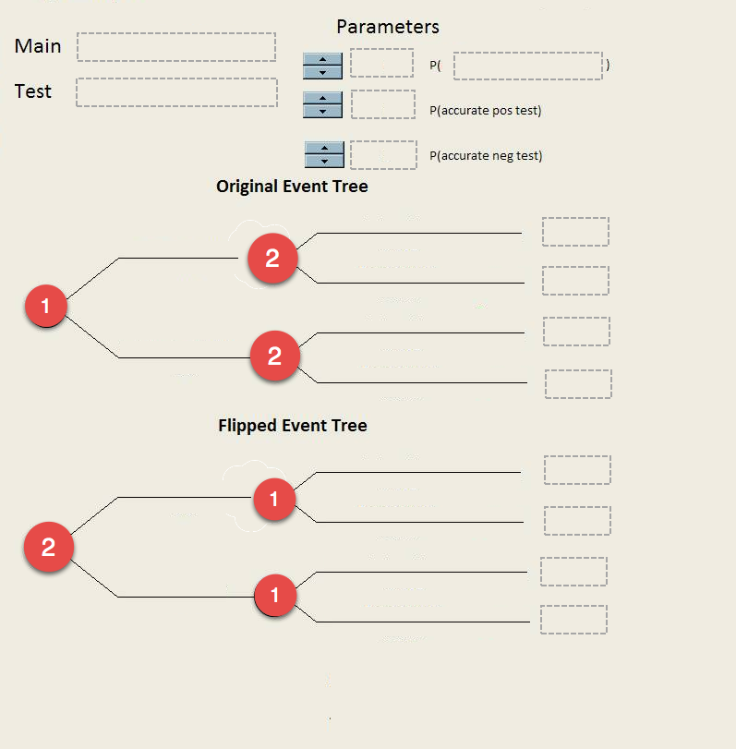

Q106. She may love you or she may not. It turns out there is a 40% chance she does. You decide to use the buttercup test to find out (hold a buttercup under chin and see if it reflects yellow). The test is 90% accurate. Draw tree and flip to determine what conclusions we can draw from positive and negative buttercup test results.

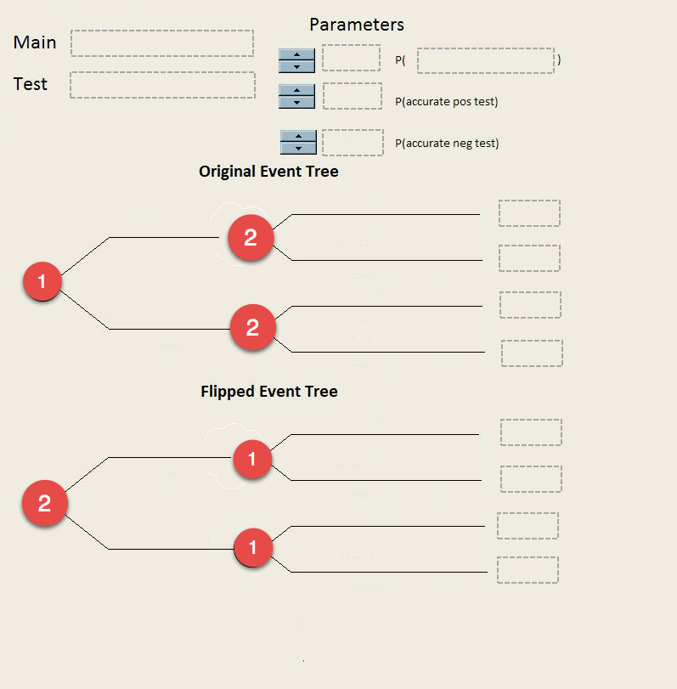

Q183. In the election between candidate A and candidate B, for voter X it comes down to what the candidate will do for the elderly. The election is a toss-up and it may well come down to X's vote. Research indicates that candidate A is quite likely (75% chance) to do 4 things for the elderly but many only end up doing one thing (25% chance). Candidate B, on the other hand, is very unlikely to do 4 things (10%) but is 90% likely to do 2 things. For whom should X vote if this is the deciding issue.

Q321.: Our consulting firm, NGOsRus, has developed a new organizational assay protocol to help characterize the financial health of community organizations. We have tested the instrument on many organizations whose financial well-being has been determined by other, much more expensive means. Here's what we know:
Healthy organizations pass the test 80% of the time but fail it 20% of the time. Unhealthy organizations fail the test 88% of the time but pass 12% of the time.
How likely is it that an organization that passes the test is, in fact, in good state financially?

